Name – Tapas Mazumdar ID – 2018A8B40427P

Analog Electronics Lab #8 – Study the sinusoidal and non-sinusoidal oscillators using LM741



**Objectives**

To study the sinusoidal and non-sinusoidal oscillators using op-amp IC LM741

1. RC phase shift oscillator
2. Wein Bridge oscillator

and draw output waveforms in each case.

Also draw the schematic for each filter and compare theoretical values with simulated ones.

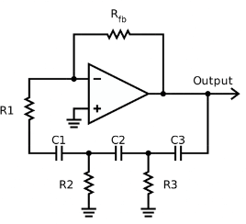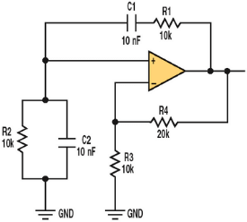

**Oscillators**

An **oscillator** is a circuit which produces a continuous, repeated, alternating waveform without any input. Oscillators basically convert unidirectional current flow from a DC source into an alternating waveform which is of the desired frequency, as decided by its circuit components.

**RC Phase shift oscillator**

**Wein Bridge oscillator**

**RC**

**phase shift oscillator**

# Schematic and waveforms

C = 0.1uF

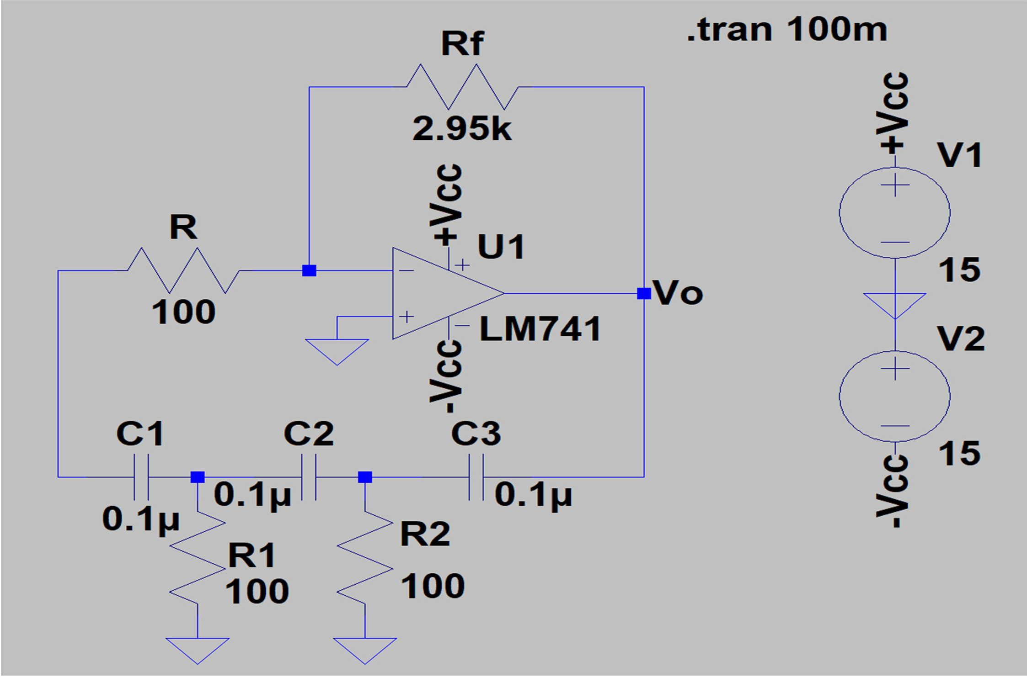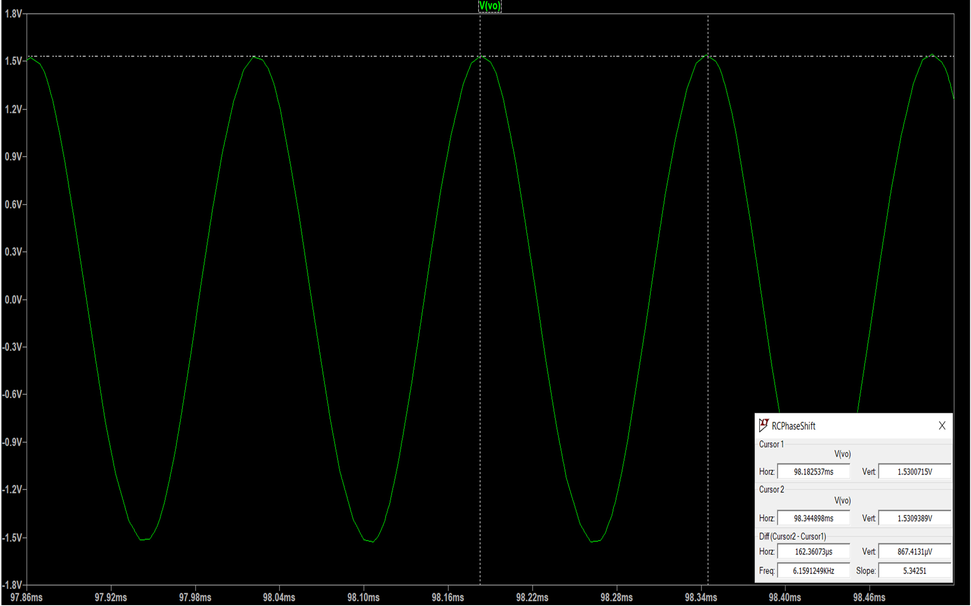

C = 0.2uF

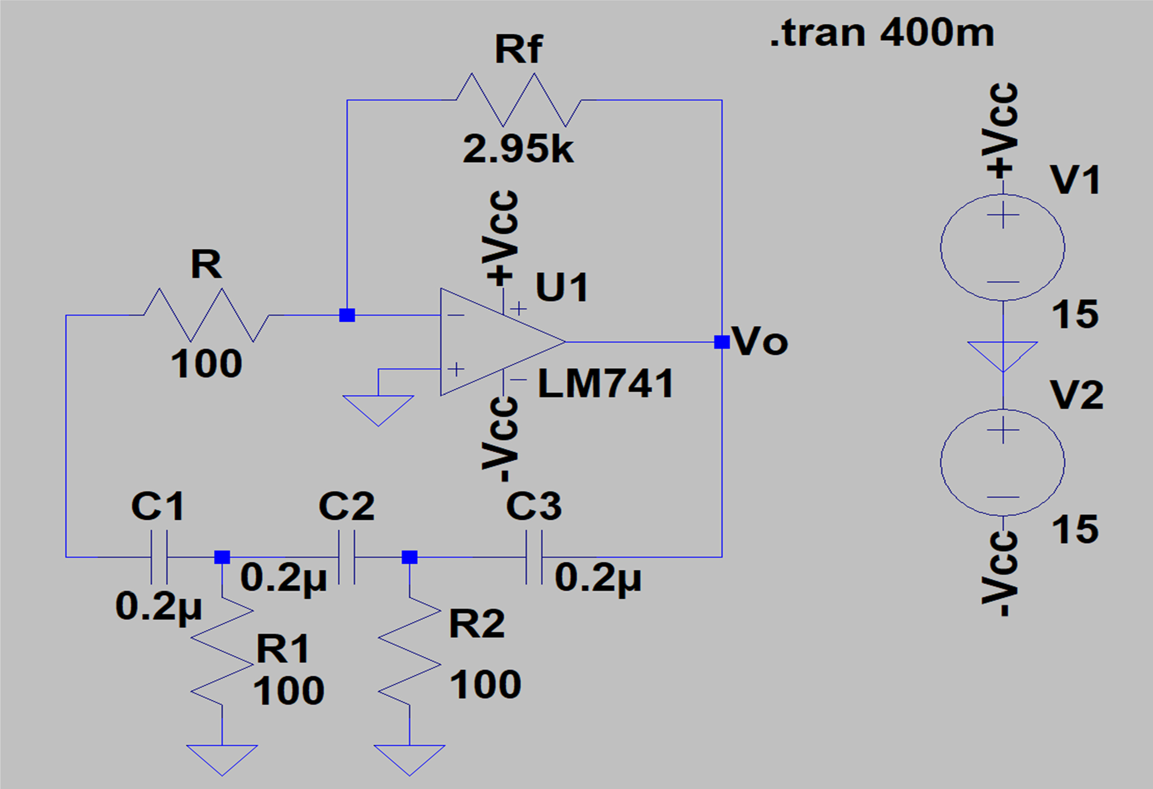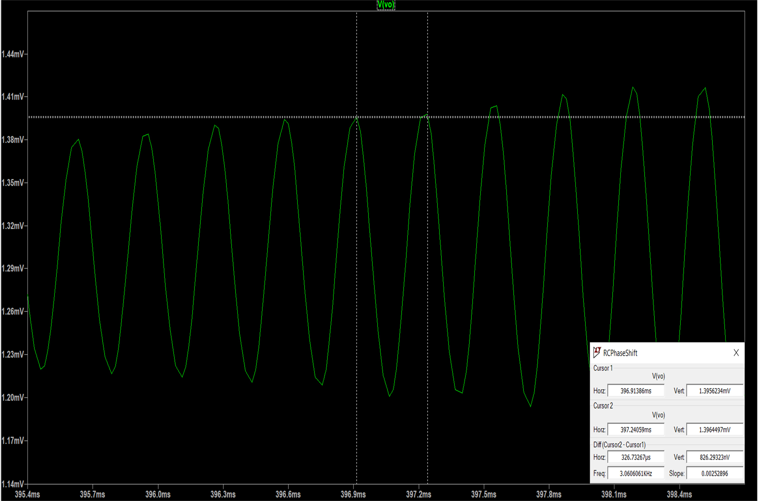

**Wein Bridge oscillator**

**Schematic and waveforms**

C = 0.1uF

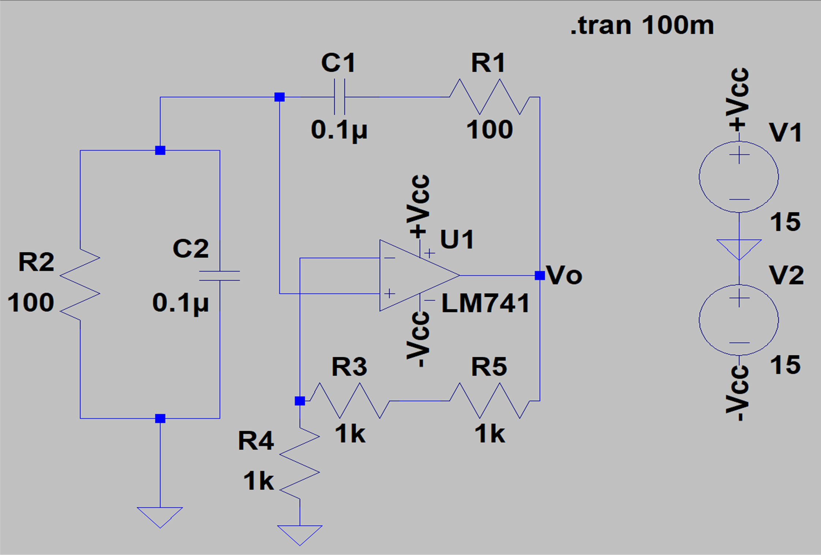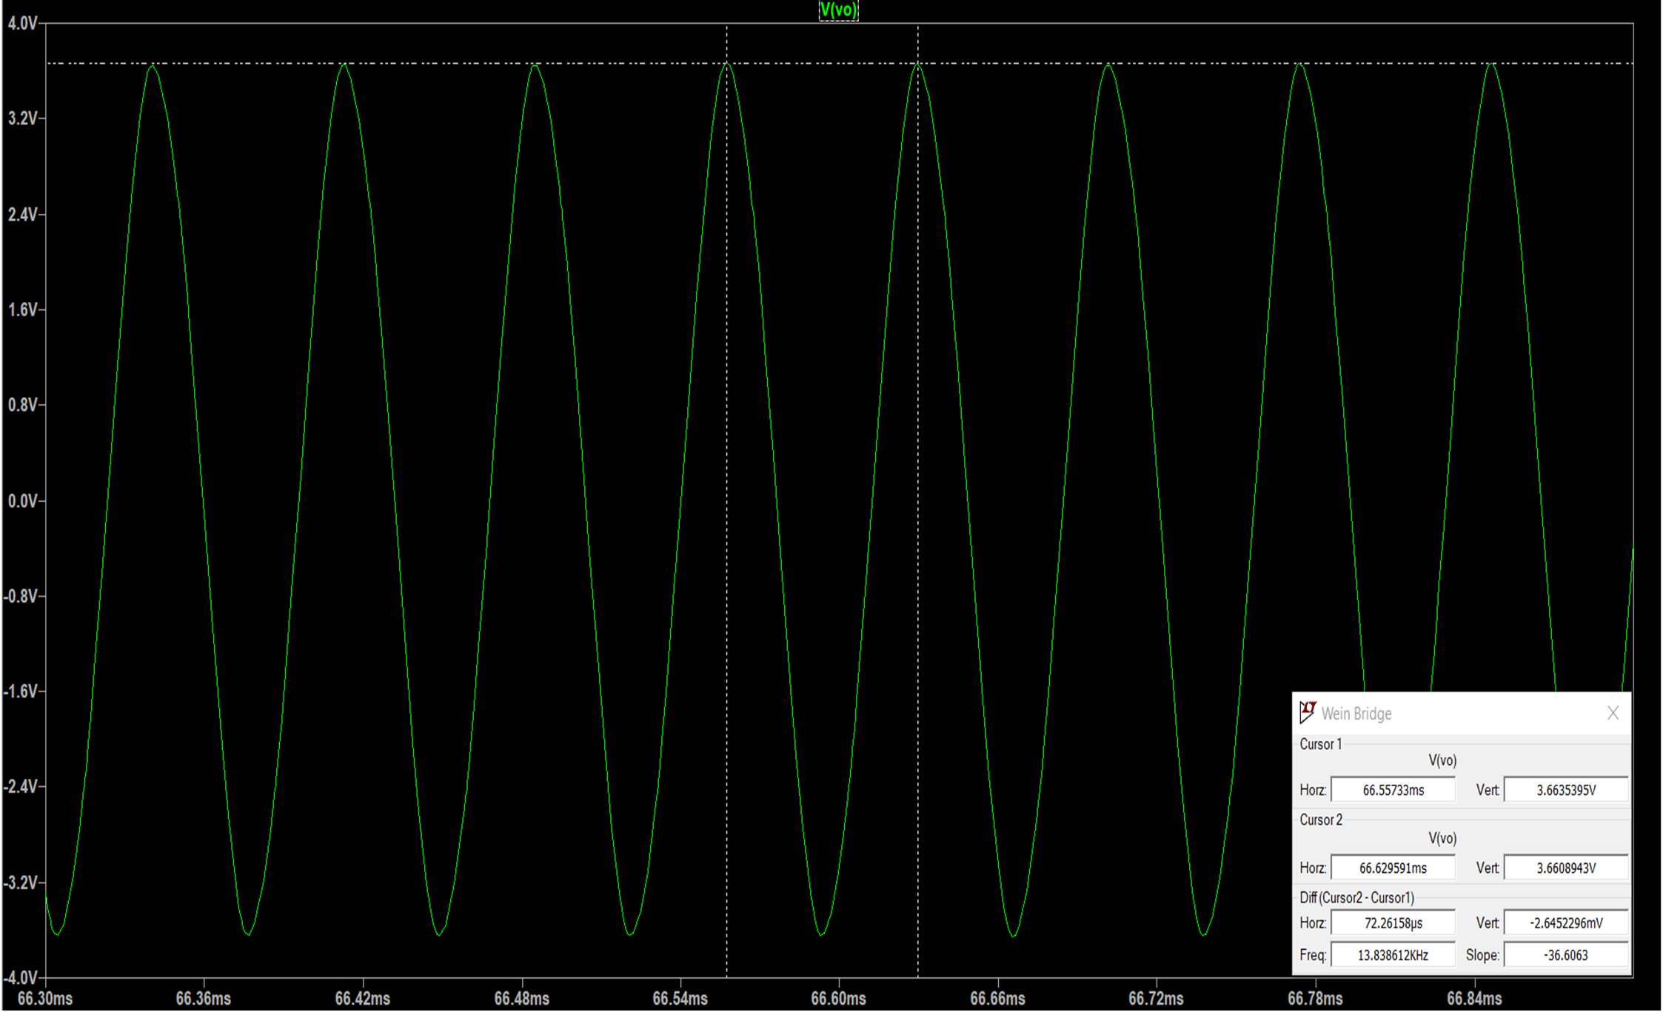

C = 0.2uF

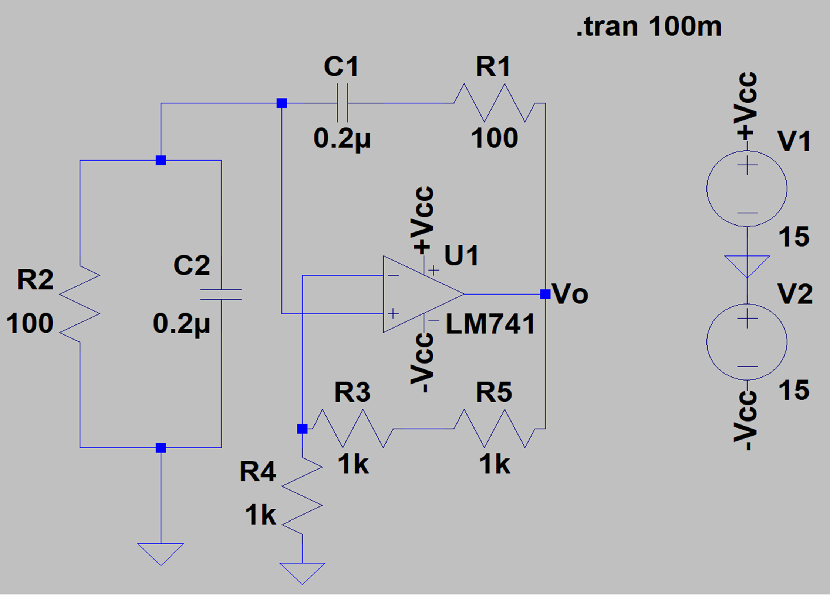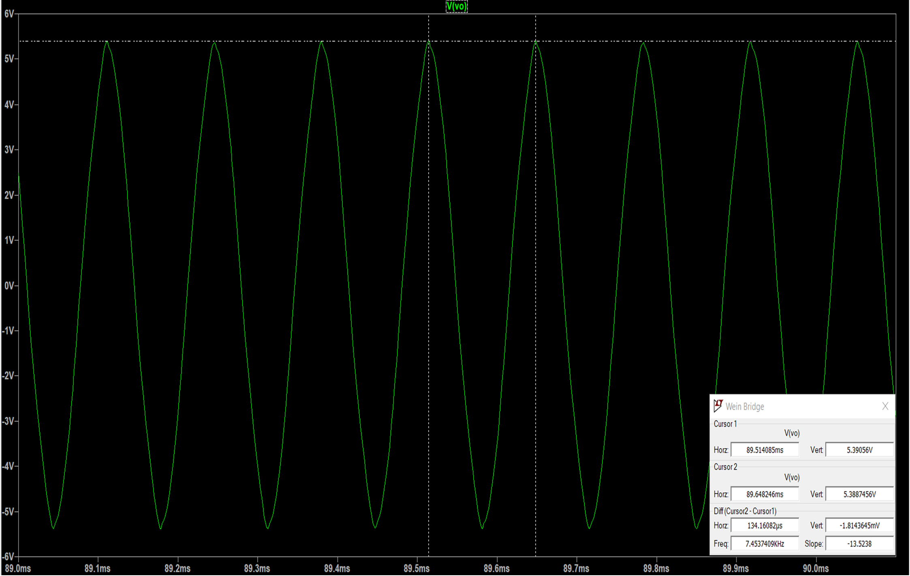

**Results**

**Comparison of simulated and theoretical values oscillator frequencies:**

|  |  |  |
| --- | --- | --- |
| **Oscillator** | **Theoretical value of oscillator frequency** | **Best simulated value**  **of oscillator frequency** |
| RC phase shift oscillator C = 0.1uF | 1 = 1 = 6.497 kHz  2π√6RC 2π × √6 × 100 × 0.1u | 6.16 kHz |
| RC phase shift oscillator C = 0.2uF | 1 = 1 = 3.249 kHz  2π√6RC 2π × √6 × 100 × 0.2u | 3.06 kHz |
| Wein Bridge oscillator C= 0.1uF | 1 = 1 = 15.915 kHz  2πRC 2π × 100 × 0.1u | 13.84 kHz |
| Wein Bridge oscillator C= 0.2uF | 1 = 1 = 7.958 kHz  2πRC 2π × 100 × 0.2u | 7.454 kHz |

**Conclusions**

The minimum value of potentiometer resistance possible is 2.95 kΩ for RC phase shift oscillator and 1 kΩ for Wein Bridge oscillator below which the simulation is not possible. The values of frequencies obtained are shown in table above. At double value of capacitor, we get approximately half the frequency as expected.